Steps to use the Generic ODATA call using CSM Connector

From Postman, we can use the Generic ODATA to perform various activity in ISM
Using Postman
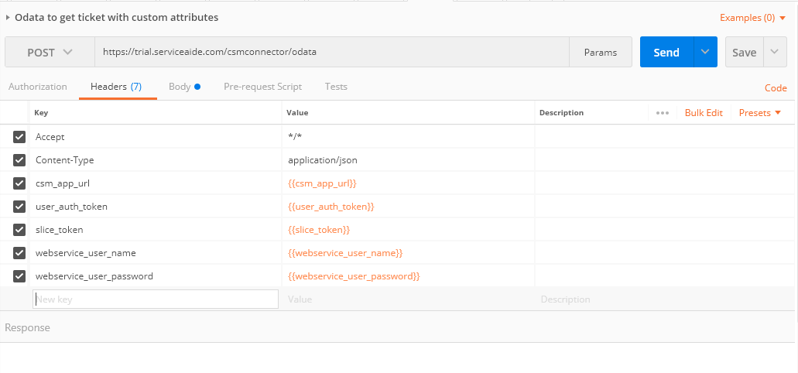
Provide the details in the Headers section for the CSM Connector, Generic ODATA call will be a POST call the below screen shot provides the complete ticket data
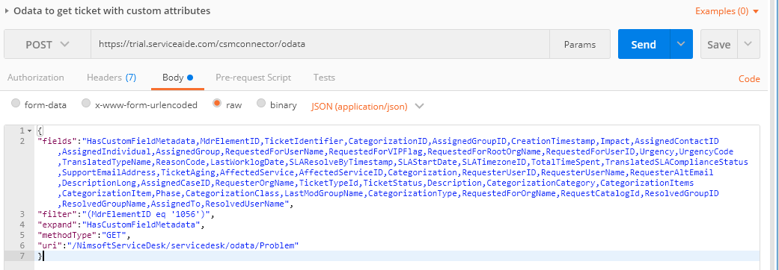

The entire content has to be send in the Body
{
"fields":"HasCustomFieldMetadata,MdrElementID,TicketIdentifier,CategorizationID,AssignedGroupID,CreationTimestamp,Impact,AssignedContactID,AssignedIndividual,
AssignedGroup,RequestedForUserName,RequestedForVIPFlag,RequestedForRootOrgName,RequestedForUserID,Urgency,UrgencyCode,TranslatedTypeName,
ReasonCode,LastWorklogDate,SLAResolveByTimestamp,SLAStartDate,SLATimezoneID,TotalTimeSpent,TranslatedSLAComplianceStatus,SupportEmailAddress,TicketAging,
AffectedService,AffectedServiceID,Categorization,RequesterUserID,RequesterUserName,RequesterAltEmail,DescriptionLong,AssignedCaseID,RequesterOrgName,TicketTypeId,
TicketStatus,Description,CategorizationCategory,CategorizationItems,CategorizationItem,Phase,CategorizationClass,LastModGroupName,CategorizationType,
RequestedForOrgName,RequestCatalogId,ResolvedGroupID,ResolvedGroupName,AssignedTo,ResolvedUserName",
"filter":"(MdrElementID eq '1056')",
"expand":"HasCustomFieldMetadata",
"methodType":"GET",
"uri":"/NimsoftServiceDesk/servicedesk/odata/Problem"
}
Fields – All the attributes which are required for the response need to be passed, if you need just the custom field meta data then we can just pass “HasCustomFieldMetadata”, this will fetch only the custom attributes details for the ticket.
URI- This need to be specific for a ticket type, the above example is for Problem, same way need to pass for ServiceRequest, Change, Incident.

